Steps to apply maintenance message on Optum :-

There are two ways to add maintenance message on Optum-

- From the back end :-

- Get access to Database of Optum.

- In the ‘Labels’ Table, find the label id of ‘Username (9-digit Employee ID)’ label text. Mostly, the label id is 1.

- Add ‘<span style="color:red">Attention: Upcoming site maintenance that may result in intermittent downtime. Maintenance window: Saturday, 10/19/19 8:00a.m. to 5:00 p.m. CST.</span><br>’ label text before the label text found for ‘Username (9-digit Employee ID)’ where time is variant, enter as per the required time frame.

- While removing the maintenance message remove the added label text from the label name ‘lblUserName’.

Note :- Please note that while removing appended maintenance message do not remove whole label text and keep "Username (9-digit Employee ID)" as remaining text for the label.

- From the front end :-

- Go to the configuration site ‘https://uat.singlestorefront.com/Optumconfiguration/login.aspx’

- Login with admin credentials.

- Navigate to Customer -> Site Management -> Click on ‘+’ icon -> Choose Labels and then click on Continue button.

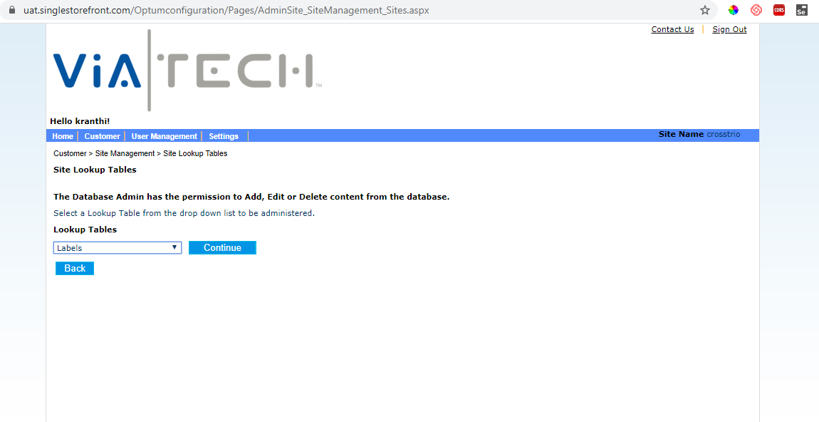
- Choose ‘Login’ page name in Page Name dropdown, ‘English’ language in Language dropdown and ‘lblUserName’ in Key Word text field.

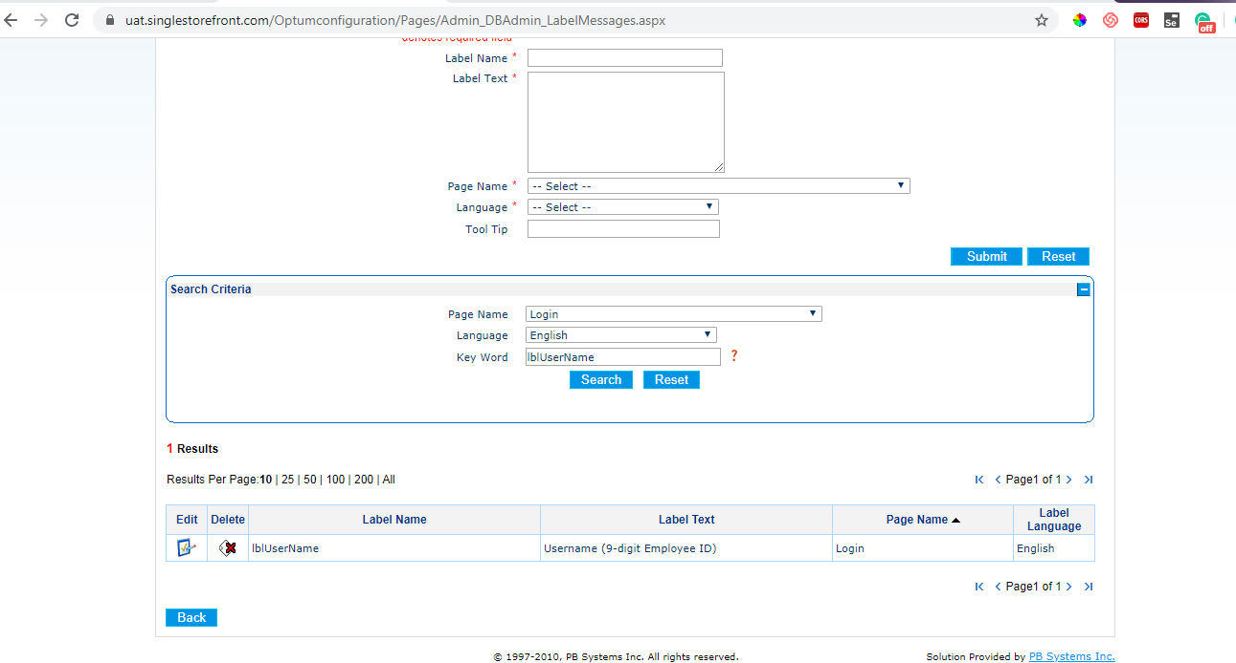

- Edit ‘lblUserName’ and add ‘<span style="color:red">Attention: Upcoming site maintenance that may result in intermittent downtime. Maintenance window: Saturday, 10/19/19 8:00a.m. to 5:00 p.m. CST.</span><br>’ text before ‘Username (9-digit Employee ID)’ text and Submit. Please note that the time can vary.

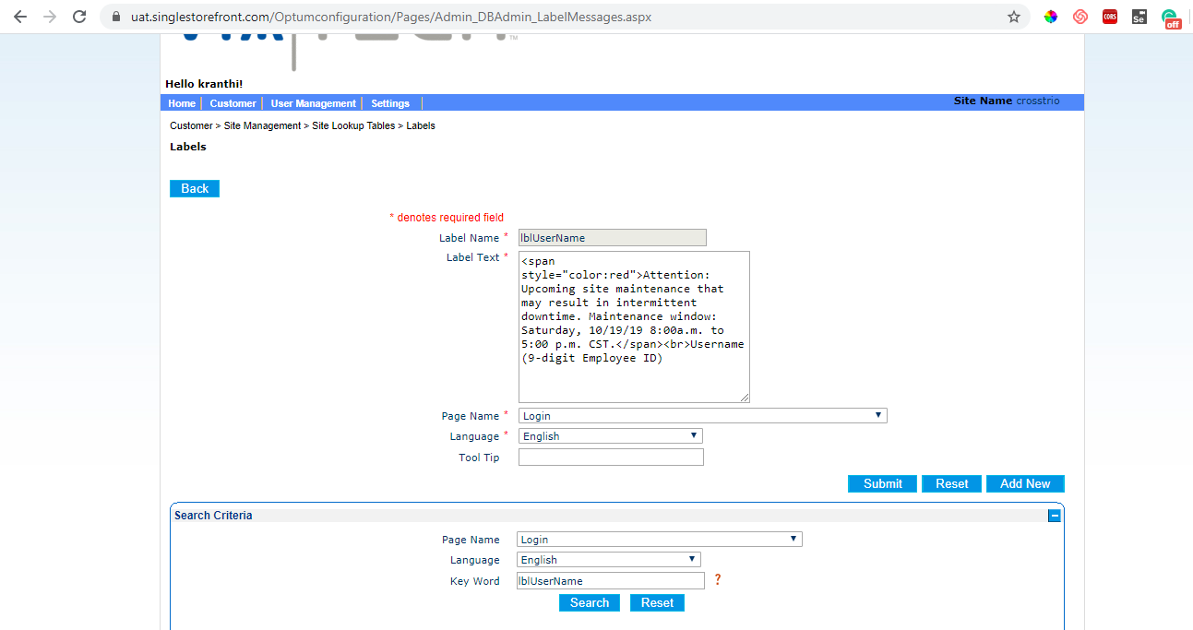

- While removing the maintenance message, remove the added text from the ‘lblUserName’ label and Save.

Note :- Please note that while removing appended maintenance message do not remove whole label text and keep "Username (9-digit Employee ID)" as remaining text for the label.

